## C:\Users\kaveti_s\Desktop\icons-facebook-facebook-icon-social-media-icon-ios-7-facebook-png--9.png

## JAVA

WEB SERVICES

/[smlcodes](https://twitter.com/smlcodes) [/smlcodes](https://www.facebook.com/SmlCodes-216971275364320/) [/smlcodes](https://www.youtube.com/channel/UCO0JjZa8BcRvc3rTe0BL9HA)



***A*** [***SmlCodes.Com***](http://www.smlcodes.com/) ***Small presentation***

In Association with Idleposts.com

## Satya Kaveti

## JAVA WEB SERVICES



**Small Codes**

Programming Simplified



Copyright © 2016 SmlCodes.com All rights Reserved.

**For more tutorials & Articles visit** [**SmlCodes.com**](http://www.smlcodes.com/)

**Copyright © 2016 Smlcodes.com**

All rights reserved. No part of this book may be reproduced, stored in a retrieval system, or transmitted in any form or by any means, **without the prior written permission** of the publisher, except in the case of brief quotations embedded in critical articles or reviews.

**Every effort has been made in the preparation of this book to ensure the accuracy of the information presented**. However, the information contained in this book is sold without warranty, either express or implied. Neither the author, SmlCodes.com, nor its dealers or distributors will be held liable for any damages caused or alleged to be caused directly or indirectly by this book.

**Smlcodes.com has endeavored to provide trademark information** about all the companies and products mentioned in this book by the appropriate use of capitals. However, SmlCodes.com Publishing cannot guarantee the accuracy of this information.

If you discover any errors on our website or in this tutorial, please notify us at [support@smlcodes.com](mailto:support@smlcodes.com) or [smlcodes@gmail.com](mailto:smlcodes@gmail.com)

**First published on** Dec 2016, Published by **SmlCodes.com**

Author Credits

Name : **Satya Kaveti**

Email : [satyakaveti@gmail.com](mailto:satyakaveti@gmail.com)

Website : smlcodes.com, satyajohnny.blogspot.com

Digital Partners



[  1](#_Toc471218896)

[JAVA 1](file:///C:\Users\kaveti_s\Desktop\WebServices%20-SmlCodes-2.docx#_Toc471218897)

[- Satya Kaveti 1](file:///C:\Users\kaveti_s\Desktop\WebServices%20-SmlCodes-2.docx#_Toc471218898)

[JAVA WEB SERVICES 1](#_Toc471218899)

[1. Introduction 4](#_Toc471218900)

[1.1 SOAP [Simple Object Access Protocol 5](#_Toc471218901)

[1.2 REST [Representation State Transfer] 7](#_Toc471218902)

[1.3 Java Web Services API 10](#_Toc471218903)

[2. JAX-WS (SOAP web services) 11](#_Toc471218904)

[2.1 Diffrence between RPC-Style and Document Style 12](#_Toc471218905)

[2.2 JAX-WS Annotations 13](#_Toc471218906)

[2.3 JAX-WS RPC Style 17](#_Toc471218907)

[2.4 JAX-WS Document Style 22](#_Toc471218908)

[2.5 JAX-WS Tools 24](#_Toc471218909)

[2.6 JAX-WS Examples 31](#_Toc471218910)

[3. JAX-RS (RESTFul web services) 32](#_Toc471218911)

[3.1 JAX-RS Annotations 33](#_Toc471218912)

[3.2 JAX-RS JERSEY 35](#_Toc471218913)

[3.3 JAX-RS RESTEasy 40](#_Toc471218914)

[3.4 JAX-RS Examples 43](#_Toc471218915)

[References 45](#_Toc471218916)

# 1. Introduction

By using webservices we can communicate different applications on different platforms. For example java application in Windows platform can easily communicate with the application developed using .net/php in Linux operation system.

Web Services are mainly of 2 types,

1. **SOAP [Simple Object Access Protocol]**
2. **REST [Representational state transfer]**

**1. SOAP [Simple Object Access Protocol]**

SOAP stands for Simple Object Access Protocol. **SOAP is an XML based** industry standard protocol for designing and developing web services. **Since it’s XML based, its platform and language independent**. So our server can be based on JAVA and client can be on .NET, PHP etc. and vice versa. **SOAP gives the output only in XML format**

**We have following API’s to implement SOAP Webservices in our java applications**

* **JAX-WS**
* **Apache Axis2**

**2. REST [Representational state transfer]**

What ever the data/response we will get from the server is known as **Resource**.Each resource can be accessed by its URI’s. We can get the resource from RESTful service in different formats like, **HTML,XML,JSON,TEXT,PDF** and in the Image formats as well, **but in real time we mainly we will prefer JSON.** REST guidelines always talks about stateless communication between client and the Server. Stateless means, every single request from client to server will be considered as a fresh request. Because of this reason REST always prefers to choose HTTP as it a stateless protocol

**We have following API’s to implement RESTful Webservices in our java applications**

* **JAX-RS**

Apache CXF provides implementation for SOAP and RESTful services both.

REST is a style of software architecture.RESTful is typically used to refer to web services implementing such an architecture

|  |  |  |
| --- | --- | --- |
| **No.** | **SOAP** | **REST** |
| 1) | SOAP is a **protocol**. | REST is an **architectural style**. |
| 2) | SOAP stands for **Simple Object Access Protocol**. | REST stands for **REpresentational State Transfer**. |
| 3) | SOAP **can't use REST** because it is a protocol. | REST **can use SOAP** web services because it is a concept and can use any protocol like HTTP, SOAP. |
| 4) | SOAP **uses services interfaces to expose the business logic**. | REST **uses URI to expose business logic**. |
| 5) | **JAX-WS** is the java API for SOAP web services. | **JAX-RS** is the java API for RESTful web services. |
| 6) | SOAP **defines standards**to be strictly followed. | REST does not define too much standards like SOAP. |
| 7) | SOAP **requires more bandwidth** and resource than REST. | REST **requires less bandwidth** and resource than SOAP. |
| 8) | SOAP **defines its own security**. | RESTful web services **inherits security measures** from the underlying transport. |
| 9) | SOAP **permits XML** data format only. | REST **permits different** data format such as Plain text, HTML, XML, JSON etc. |
| 10) | SOAP is **less preferred** than REST. | REST **more preferred** than SOAP. |

## 1.1 SOAP [Simple Object Access Protocol

Simple Object Access Protocol (SOAP) is a standard protocol specification for message exchange based on XML. Communication between the web service and client happens using XML messages.

A simple web service architecture have two components

1. **Client**
2. **Service provider**

**To communicate clinet with service provider clinet must know about following things**

* Location of webservices server
* Functions available, signature and return types of function.
* Communication protocol
* Input output formats

**Service provider will create a standard XML file which will have all above information**.So if this file is given to client then client will be able to access web service. **This XML file is called “WSDL”**.

**WSDL (Web Services Description Language):**

WSDL stands for **Web Service Description Language**. It is **an XML file that describes the technical details** of how to implement a web service, more specifically the **URI, port, method names, arguments, and data types**. Since WSDL is XML, it is both human-readable and machine-consumable, which aids in the ability to call and bind to services dynamically.using this WSDL file we can understand things like,

* Port / Endpoint – URL of the web service
* Input message format
* Output message format
* Security protocol that needs to be followed
* Which protocol the web service uses

### How to access web service:

There are two ways to access web service

1. **If Service provider knows client**
2. **If Service provider register its WSDL to UDDI and client can access it from UDDI**

1. If Service provider knows client

**If Service provider knows client** then it will provide its wsdl to client and client will be able to access web service.

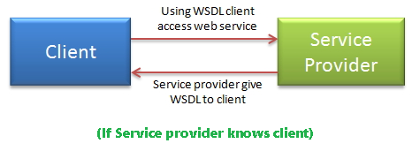

2. If Service provider register its WSDL to UDDI and client can access it from UDDI

**Service provider register its WSDL to UDDI and client can access it from UDDI**:UDDI stands for Universal Description, Discovery and Integration.It is a directory service. Web services can register with a UDDI and make themselves available through it for discovery.So following steps are involved.

1. ***Service provider registers with UDDI.***
2. ***Client searches for service in UDDI.***
3. ***UDDI returns all service providers offering that service.***
4. ***Client chooses service provider***
5. ***UDDI returns WSDL of chosen service provider.***
6. ***Using WSDL of service provider,client accesses web service***

**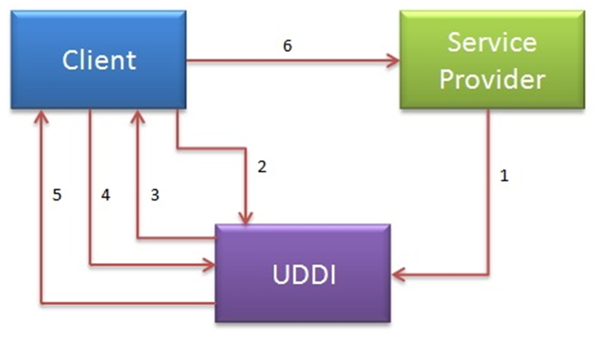**

**UDDI:**

* UDDI is an XML-based standard for describing, publishing, and finding web services.
* UDDI is a specification for a distributed registry of web services

A business or a company can register three types of information into a UDDI registry. This information is contained in three elements of UDDI.

These three elements are:

1. **White Pages** : Basic information about the company and its business
2. **Yellow Pages**: contain more details about the company
3. **Green Pages**: contains technical information about a web service(url locations etc)

Now SOAP useswithout WSDL and UDDI. Instead of the discovery process described in the History of the Web Services Specification section below, SOAP messages are hard-coded or genereated without the use of a repository. The interaction is illustrated in the figure below. More on SOAP.

## 1.2 REST [Representation State Transfer]

**REpresentational State Transfer (REST)** is a stateless client-server architecture in which the web services are viewed as **resources** and can **be identified by their URIs.**Web service clients that want to use these resources access via globally defined set of remote methods that describe the action to be performed on the resource.

It consists of two components

1. **REST server:** which provides access to the resources
2. **REST client** : which accesses and modify the REST resources.

In the REST architecture style, clients and servers exchange result representations of resources by using a standardized interface and protocol**.REST isn't protocol specific, but when people talk about REST they usually mean REST over HTTP.**

The response from server is considered as the result representation of the resources. This result representation can be generated from one resource or more number of resources. REST allows that resources have different result representations, **e.g.xml, json etc**. The rest client can ask for specific result representation via the HTTP protocol

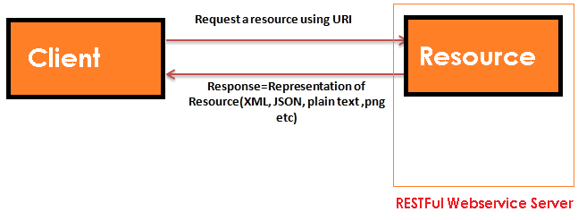

### HTTP methods:

RESTful web services use HTTP protocol methods for the operations they perform.

Methods are:

* **GET**:It defines a reading access of the resource without side-effects.This operation is idempotent i.e.they can be applied multiple times without changing the result
* **PUT**:  It is generally used for updating resouce.It must also be idempotent.
* **DELETE:** It removes the resources. The operations are idempotent i.e. they can get repeated without leading to different results.
* **POST**: It is used for creating a new resource. It is not idempotent.

### Idempotent

Idempotent means result of multiple successful request will not change state of resource after initial application

**For example:**

**GET is idempotent.** If Delete() is idempotent method because when you first time use delete, it will delete the resource (initial application) but after that, all other request will have no result because resource is already deleted.

**Post is not idempotent** method because when you use post to create resource, it will keep creating resource for each new request, so result of multiple successful request will not be same.

Some important features of Restful web services are:

**1.Resource identification through URI**:Resources are identified by their URIs (typically links on internet). So, a client can directly access a RESTful Web Services using the URIs of the resources (same as you put a website address in the browser’s address bar and get some representation as response).

**2.Uniform interface:** Resources are manipulated using a fixed set of four create, read, update, delete operations: PUT, GET, POST, and DELETE.

**3.Client-Server:** A clear separation concerns is the reason behind this constraint. Separating concerns between the Client and Server helps improve portability in the Client and Scalability of the server components.

**4.Stateless:** each request from client to server must contain all the information necessary to understand the request, and cannot take advantage of any stored context on the server.

**5.Cache:** to improve network efficiency responses must be capable of being labeled as cacheable or non-cacheable.

**6.Named resources** - the system is comprised of resources which are named using a URL.

**7.Interconnected resource representations** - the representations of the resources are interconnected using URLs, thereby enabling a client to progress from one state to another.

**8.Layered components** - intermediaries, such as proxy servers, cache servers, gateways, etc, can be inserted between clients and resources to support performance, security, etc.

**9.Self-descriptive messages**: Resources are decoupled from their representation so that their content can be accessed in a variety of formats, such as HTML, XML, plain text, PDF, JPEG, JSON, and others.

## 1.3 Java Web Services API

Java web services tutorial provides concepts and examples of two main java web services api: **JAX-WS and JAX-RS**. The java web service application can **be accessed by other programming languages such as .Net and PHP.**

Java web service application perform communication through **WSDL (Web Services Description Language).** There are two ways to write java web service application code**: SOAP and RESTful**.

There are two main API's defined by Java for developing web service applications since JavaEE 6.

1. **JAX-WS:** for SOAP web services. The **are 2 ways to write JAX-WS** application code: by
   * 1. ***RPC style***
     2. ***Document style.***
2. **JAX-RS:** for RESTful web services. There are **mainly 2 implementation** currently in use for creating **JAX-RS** application:
   * 1. ***Jersey***
     2. ***RESTeasy***.

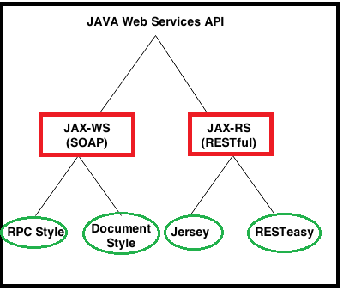

We have some other RESTFul webservices providers like

* ***Jersey***
* ***RestEasy***
* ***Restlet***
* ***CFX***
* ***Spring Rest webservices***

# 2. JAX-WS (SOAP web services)

SOAP stands for Simple Object Access Protocol. It is a XML-based protocol for accessing web services.

SOAP is a W3C recommendation for communication between two applications.

SOAP is XML based protocol. It is platform independent and language independent. By using SOAP, you will be able to interact with other programming language applications.

**Advantages of Soap Web Services**

* **WS Security**: SOAP defines its own security known as WS Security.
* **Language and Platform independent**: SOAP web services can be written in any programming language and executed in any platform

There are two ways to develop JAX-WS example.

1. **RPC style**
2. **Document style**

**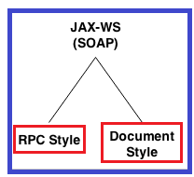**

There are two encoding use models that are used to translate a WSDL binding to a SOAP message. They are: **literal, and encoded.**

The combination of the different style and use models give us four different ways to translate a WSDL binding to a SOAP message.

Document/literal

Document/encoded

RPC/literal

RPC/encoded

**When using a** **literal use model**, the body contents should conform to a user-defined **XML-schema (XSD) structure**. The advantage is two-fold. For one, you can validate the message body with the user-defined XML-schema, moreover, you can also transform the message using a transformation language like XSLT.

**With a (SOAP) encoded use model**, the message has to use XSD datatypes, but the structure of the message need not conform to any user-defined XML schema. This makes it difficult to validate the message body or use XSLT based transformations on the message body.

## 2.1 Diffrence between RPC-Style and Document Style

**The way of generating SOAP message formate is main difffrence beteween them.**

**1. RPC Stlye**:

SOAP Body must conform to a structure that indicates the **method name & Parameters name**

<soap:envelope>

<soap:body>

<myMethod>

<x xsi:type="xsd:int">5</x>

<y xsi:type="xsd:float">5.0</y>

</myMethod>

</soap:body>

</soap:envelope>

**2. Document Style**

**SOAP Body can be structurted in any way you like.their is no TYPE attribute here**

<soap:envelope>

<soap:body>

<xElement>5</xElement>

<yElement>5.0</yElement>

</soap:body>

</soap:envelope>

## 2.2 JAX-WS Annotations

We have following important annonotations in order to workwith JAX-WS webservices. They are

1. **@WebService**
2. **@SoapBinding**
3. **@WebMethod**
4. **@WebResult**
5. **@WebServiceClient**
6. **@RequestWrapper**
7. **@ResponseWrapper**
8. **@Oneway**
9. **@HandlerChain**

**1.@WebService**

This annotation can be used in 2 ways

**1.To mark the class as the implementing the Web Service**

Package webservice;

import javax.jws.WebMethod;

import javax.jws.WebService;

import javax.jws.soap.SOAPBinding;

import javax.jws.soap.SOAPBinding.Style;

@WebService

@SOAPBinding(style=Style.RPC)

public interface HelloWorld {

@WebMethod

String getHelloworldMessage(String msg);

}

**2.Defining a Web Service Interface (SEI), in other words Service Endpoint Interface**

import javax.jws.WebService;

@WebService(endpointInterface="webservice.HelloWorld ")

public class HelloWorldImpl implements HelloWorld{

@Override

public String getHelloworldMessage (String name) {

return "Hello World JAX-WS " + name;

}

}

**@Webservice with all attributes as below formate**

@WebService(portName = "SoapPort", serviceName = " HelloWorld ",

targetNamespace = "http://apache.org/hello\_world\_soap\_http",

endpointInterface="webservice.HelloWorld ")

**2.@SoapBinding**

This annotation is used to specify the SOAP messaging style which can either be **RPC** or **DOCUMENT**

/Service Endpoint Interface

@WebService

@SOAPBinding(style = Style.RPC)

//@SOAPBinding(style = Style. DOCUMENT)

public interface HelloWorld{

@WebMethod

String getHelloWorldAsString(String name);

}

**@SoapBinding with all attributes as below formate**

@SOAPBinding(style=SOAPBinding.Style.DOCUMENT,  
 use=SOAPBinding.Use.LITERAL,  
 parameterStyle=SOAPBinding.ParameterStyle.WRAPPED)

**3.@WebMethod**

**@WebMethod** JAX-WS annotation can be applied over a method only. This specified that the method represents a web service operation.it will be used in Interface(***Service Endpoint Interface***) level method only, not in implementation method level.()

/Service Endpoint Interface

@WebService

public interface HelloWorld{

@WebMethod

String getHelloWorldAsString(String name);

}

@**WebMethod** **with all attributes as below formate**

@WebMethod(operationName="echoComplexType", action=” SOAPAction”)

**4.@WebResult**

@WebResult can be used to determine **what the generated WSDL shall look like**

@WebService

public interface HelloWorld{

@WebMethod

@WebResult(partName="Helloworld Method")

String getHelloWorldAsString(String name);

}

//Service Implementation

@WebService(endpointInterface = "com.mkyong.ws.HelloWorld")

public class HelloWorldImpl implements HelloWorld{

@Override

public String getHelloWorldAsString(String name) {

return "Hello World JAX-WS " + name;

}

}

public class WSPublisher {

public static void main(String[] args) {

Endpoint.publish("http://127.0.0.1:9999/ctf", new getHelloWorldAsString ());

}

}

On publishing the generated WSDL (at URL: http://127.0.0.1:9999/ctf?wsdl) would be like:

<definitions

xmlns:wsu="http://docs.oasis-open.org/wss/2004/01/oasis-200401-wss-wssecurity-utility-1.0.xsd"

xmlns:wsp="http://www.w3.org/ns/ws-policy" xmlns:wsp1\_2="http://schemas.xmlsoap.org/ws/2004/09/policy"

xmlns:wsam="http://www.w3.org/2007/05/addressing/metadata" xmlns:soap="http://schemas.xmlsoap.org/wsdl/soap/"

xmlns:tns="http://webresult.jaxWsAnnotations.examples.smlcodes.com/"

xmlns:xsd="http://www.w3.org/2001/XMLSchema" xmlns="http://schemas.xmlsoap.org/wsdl/"

targetNamespace="http://webresult.jaxWsAnnotations.examples.smlcodes.com/"

name="WSAnnotationsWebResultImplService">

<types />

<message name=" getHelloWorldAsString ">

<part name="arg0" type="xsd: string " />

</message>

<message name=" Helloworld Method ">

<part name=" getHelloWorldAsString " type="xsd:string" />

</message>

</definitions>

[**5.@WebServiceClient**](mailto:5.@WebServiceClient)

@WebServiceClient(name = "WsAnnotationsWebServiceImplService", targetNamespace = "http://webservice.smlcodes.com/", wsdlLocation = "file:/Users/satyakaveti/Downloads/ctf.wsdl")

The information specified in this annotation helps in identifying a wsdl:service element inside a WSDL document. This element represents the Web service for which the generated service interface provides a client view.

**6.@RequestWrapper**

**@RequestWrapper** JAX-WS annotation is used to annotate methods in the Service Endpoint Interface with the request wrapper bean to be used at runtime. It has 4 optional elements; **className** that represents the request wrapper bean name, **localName** that represents element’s local name, **partName** that represent the part name of the wrapper part in the generated WSDL file, and**targetNamespace** that represents the element’s namespace

@WebService

@SOAPBinding(style=Style.RPC)

public interface WSRequestWrapperInterface {

@WebMethod

@RequestWrapper(localName="CTF",

targetNamespace="http://smlcodes.com/tempUtil",

className="com.smlcodes.examples.jaxWsAnnotations.webservice.CTF")

float celsiusToFarhenheit(float celsius);

}

**7.@ResponseWrapper**

@ResponseWrapper JAX-WS annotation is used to annotate methods in the Service Endpoint Interface with the response wrapper bean to be used at runtime. It has 4 optional elements; className that represents the response wrapper bean name, localName that represents element’s local name, partName that represent the part name of the wrapper part in the generated WSDL file, and targetNamespace that represents the element’s namespace.

public interface WSResponseWrapperInterfaceI {

@WebMethod

@ResponseWrapper(localName="CTFResponse",

targetNamespace="http:// smlcodes.com/tempUtil",

className="com. smlcodes.examples.jaxWsAnnotations.webservice.CTFResponse")

float celsiusToFarhenheit(float celsius);

}

**8.@Oneway**

@Oneway JAX-WS annotation is applied to WebMethod which means that method will have only input and no output. When a @Oneway method is called, control is returned to calling method even before the actual operation is performed. It means that nothing will escape method neither response neither exception.

@WebService

@SOAPBinding(style = Style.RPC)

public interface WSAnnotationsOnewayI {

@WebMethod

@Oneway

void sayHello();

}

**9.@HandlerChain**

Web Services and their clients may need to access the SOAP message for additional processing of the message request or response. A SOAP message handler provides a mechanism for intercepting the SOAP message during request and response.

A handler at server side can be a validator. Let’s say we want to validate the temperature before the actual service method is called. To do this our validator class shall implement interface SOAPHandler

package handler;

public class TemperatureValidator implements SOAPHandler {

@Override

public boolean handleMessage(SOAPMessageContext context) {

// TODO Auto-generated method stub

return false;

}

@Override

public boolean handleFault(SOAPMessageContext context) {

// TODO Auto-generated method stub

return false;

}

@Override

public void close(MessageContext context) {

// TODO Auto-generated method stub

}

@Override

public Set getHeaders() {

// TODO Auto-generated method stub

return null;

}

}

// soap-handler.xml

<?xml version="1.0" encoding="UTF-8" standalone="yes"?>

<javaee:handler-chains xmlns:javaee="http://java.sun.com/xml/ns/javaee"

xmlns:xsd="http://www.w3.org/2001/XMLSchema">

<javaee:handler-chain>

<javaee:handler>

<javaee:handler-class>com.smlcodes.examples.jaxWsAnnotations.handler.TemperatureValidator

</javaee:handler-class>

</javaee:handler>

</javaee:handler-chain>

</javaee:handler-chains>

package handler;

@WebService

@SOAPBinding(style = Style.RPC)

public interface WSAnnotationsHandlerChainI {

@HandlerChain(file = "soap-handler.xml")

@WebMethod

float celsiusToFarhenheit(float celsius);

}

## 2.3 JAX-WS RPC Style

1. RPC style web services use **method name and parameters to generate XML structure**.
2. The generated **WSDL is difficult to be validated against schema**.
3. In RPC style, **SOAP message is sent as many elements**.
4. RPC **style message is tightly coupled.**
5. In RPC style, **SOAP message keeps the operation name**.
6. In RPC style, **parameters are sent as discrete values**.

Steps to create JAX-WS RPC Style Example

**1. JAX-WS Web Service End Point files**

1. Create a Web Service Endpoint Interface with **@SOAPBinding(style = Style.RPC)**

2. Create a Web Service Endpoint Implementation

3. Create an Endpoint Publisher

4. Test generated WSDL. Ex: **http://localhost:8080/ws/hello?wsdl**

**2. Web Service Client files**

1. Java Web Service Client

In general words, “web service endpoint” is a service which published outside for user to access; where “web service client” is the party who access the published service.

### Example : Hello World using JAX-WS RPC Style

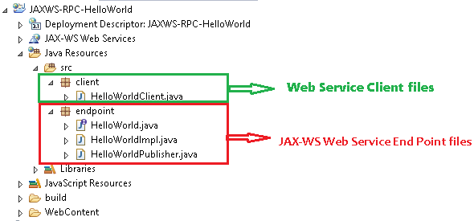

**1. JAX-WS Web Service End Point files**

**1. Create a Web Service Endpoint Interface**

package endpoint;

import javax.jws.WebMethod;

import javax.jws.WebService;

import javax.jws.soap.SOAPBinding;

import javax.jws.soap.SOAPBinding.Style;

//Service Endpoint Interface

@WebService

@SOAPBinding(style = Style.*RPC*)

public interface HelloWorld{

@WebMethod

String getHelloWorldMsg(String msg);

}

**2. Create a Web Service Endpoint Implementation**

package endpoint;

import javax.jws.WebService;

//Service Implementation

@WebService(endpointInterface = "endpoint.HelloWorld")

public class HelloWorldImpl implements HelloWorld{

@Override

public String getHelloWorldMsg(String msg) {

// TODO Auto-generated method stub

return "Your Message from WebService is : "+msg;

}

}

**3. Create an Endpoint Publisher**

package endpoint;

import javax.xml.ws.Endpoint;

//Endpoint publisher

public class HelloWorldPublisher{

public static void main(String[] args) {

Endpoint.*publish*("http://localhost:7777/ws/hello", new HelloWorldImpl());

System.*out*.println("WSDL Published !!");

}

}

**4. Test generated WSDL**

Run HelloWorldPublisher as Java Application & access url: [***http://localhost:7777/ws/hello?wsdl***](http://localhost:7777/ws/hello?wsdl)

**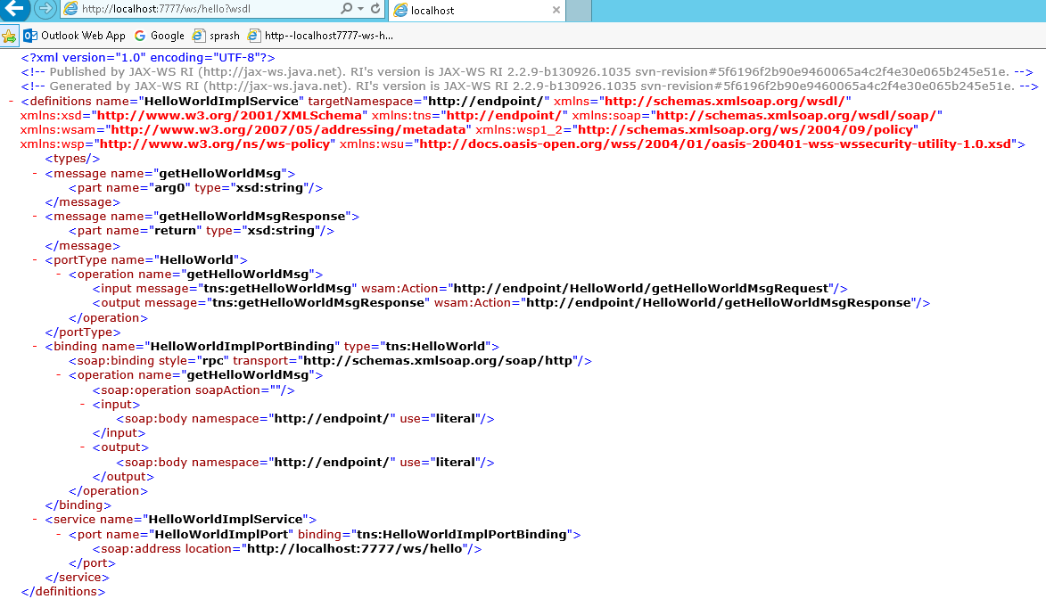**

<http://endpoint/>" uses package name of Service endpoint publisher

the main components of WSDL documents are as below. 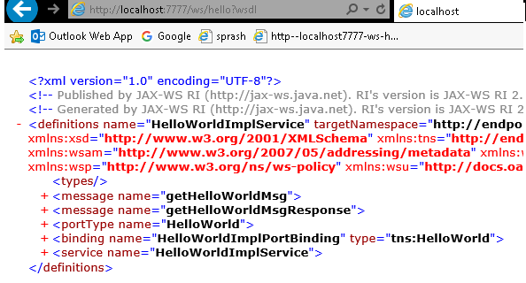



WSDL Explanation

1. first Meaage part contains service method name & parameter list

[**<message name="getHelloWorldMsg">**](http://localhost:7777/ws/hello?wsdl)

**<part name="arg0" type="xsd:string"/>**

**</message>**

2. Second Meaage part contains autogenerated Response method & return type

[**<message name="getHelloWorldMsgResponse">**](http://localhost:7777/ws/hello?wsdl)

**<part name="return" type="xsd:string"/>**

**</message>**

3. PortType information is about ServiceEndpoint interface & input,output action urls

[<portType name="**HelloWorld**">](http://localhost:7777/ws/hello?wsdl)

[<operation name="**getHelloWorldMsg**">](http://localhost:7777/ws/hello?wsdl)

<input message="**tns:getHelloWorldMsg**" wsam:Action="**http://endpoint/HelloWorld/getHelloWorldMsgRequest**"/>

<output message="**tns:getHelloWorldMsgResponse**" wsam:Action="**http://endpoint/HelloWorld/getHelloWorldMsgResponse**"/>

</operation>

</portType>

Here [http://**endpoint**](http://endpoint) **it will take package name as automatically if we won’t provide anything**

4. Binding will generate automatically by taking RPC Style/ Document Style

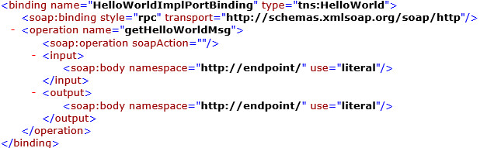

5. Service tag contains service details & WSDL document location

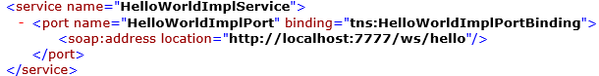

**2. Web Service Client file**

Follow below steps to write Webservice client

1. Create **URL** object by passing WSDL document location

URL url = **new** URL("http://localhost:7777/ws/hello?wsdl");

1. Create **QName** by passing service URI, Service name as arguments

QName qname = **new** QName("http://endpoint/", "HelloWorldImplService");

1. Create Service Object by **calling create(-,-)** by passing URL,QName as arguments. Service objects provide the client view of a Web service. ports available on a service can be enumerated using the getPorts method

Service service = Service.*create*(url, qname);

HelloWorld hello = service.getPort(HelloWorld.**class**);

package client;

import java.net.URL;

import javax.xml.namespace.QName;

import javax.xml.ws.Service;

import endpoint.HelloWorld;

public class HelloWorldClient{

public static void main(String[] args) throws Exception {

URL url = new URL("http://localhost:7777/ws/hello?wsdl");

//1st argument service URI, refer to wsdl document above

//2nd argument is service name, refer to wsdl document above

QName qname = new QName("http://endpoint/", "HelloWorldImplService");

Service service = Service.*create*(url, qname);

HelloWorld hello = service.getPort(HelloWorld.class);

System.*out*.println(hello.getHelloWorldMsg("Hello, from Client"));

}

}

By running Clinet application we will get output as below

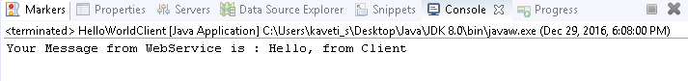

## 2.4 JAX-WS Document Style

1. **SOAP Body can be structurted in any way you like**
2. Document style web services can be **validated against predefined schema**.
3. In document style, **SOAP message is sent as a single document**.
4. Document **style message is loosely coupled**.
5. In Document style, SOAP message loses the operation name.
6. In Document style, parameters are sent in XML format.

In JAX-WS development, convert from “*RPC style*” to “*Document style*” is very easy, just change the @SOAPBinding style option

### Example

**1. JAX-WS Web Service End Point files**

1. Create a Web Service Endpoint Interface with **@SOAPBinding(style = Style.Document)**

package endpoint;

import javax.jws.WebMethod;

import javax.jws.WebService;

import javax.jws.soap.SOAPBinding;

import javax.jws.soap.SOAPBinding.Style;

//Service Endpoint Interface

@WebService

@SOAPBinding(style = Style.*DOCUMENT*)

public interface HelloWorld{

@WebMethod

String getHelloWorldMsg(String msg);

}

2. Create a Web Service Endpoint Implementation

package endpoint;

import javax.jws.WebService;

//Service Implementation

@WebService(endpointInterface = "endpoint.HelloWorld")

public class HelloWorldImpl implements HelloWorld{

@Override

public String getHelloWorldMsg(String msg) {

// TODO Auto-generated method stub

return "Your Message from WebService is : "+msg;

}

}

3. Create an Endpoint Publisher & Run as Java Application

package endpoint;

import javax.xml.ws.Endpoint;

//Endpoint publisher

public class HelloWorldPublisher{

public static void main(String[] args) {

Endpoint.*publish*("http://localhost:7771/ws/hellodoc", new HelloWorldImpl());

System.*out*.println("WSDL Published !!");

}

}

4. Test generated WSDL. Ex: http://localhost:7771/ws/hellodoc**?wsdl**

****

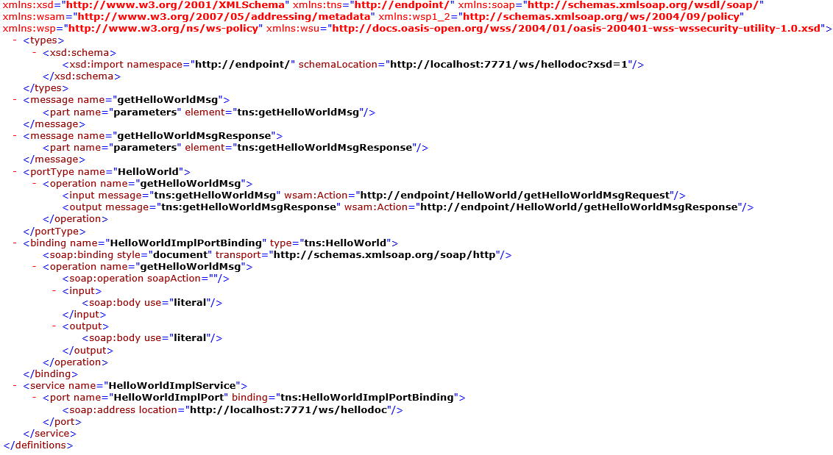

**2. Web Service Client files**

Create Java Web Service Client & Run as Java Application

package client;

import java.net.URL;

import javax.xml.namespace.QName;

import javax.xml.ws.Service;

import endpoint.HelloWorld;

public class HelloWorldClient{

public static void main(String[] args) throws Exception {

URL url = new URL("http://localhost:7771/ws/hellodoc?wsdl");

//1st argument service URI, refer to wsdl document above

//2nd argument is service name, refer to wsdl document above

QName qname = new QName("http://endpoint/", "HelloWorldImplService");

Service service = Service.*create*(url, qname);

HelloWorld hello = service.getPort(HelloWorld.class);

System.*out*.println(hello.getHelloWorldMsg("Hello, from Client"));

}

}



## 2.5 JAX-WS Tools

So far we created WebService applications manually. We have some tools to generate web service classes.lets start understanding them

### 2.5.1 wsimport tool

The **wsimport** tool is used to parse an existing Web Services Description Language (WSDL) file and generate required files (JAX-WS portable artifacts & JAX-WS Web Service End Point files).

We have to write web service client to access the published web services. This wsimport tool is available in the **$JDK/bin(**C:\Users\kaveti\_s\Desktop\Java\JDK 8.0\bin\wsimport.exe) folder. We no need add these tools to PATH,because they are built in tools

In this example we are using JAXWS-Doc-HelloWorld published WSDL to generate JAX-WS portable artifacts. The WSDL URL is

To generate JAX-WS portable artifacts using wsimport tool follow below steps

1. Create an Empty Project & create endpoint package for saving generated artifacts**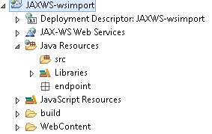**

2. **Open command promt🡪 go to project location run wsimport with wsdl doc location as below**

**wsimport wsdl-location-path -d -keep**

* **wsdl-location-path** : Is the location of wsdl file existence.
* **-d** : specify the directory where all the generated classes should be placed.
* **-keep** : It will keep the java source code of generated classes in the respective directory mentioned.

**>wsimport -keep http://localhost:7777/ws/hello?wsdl**

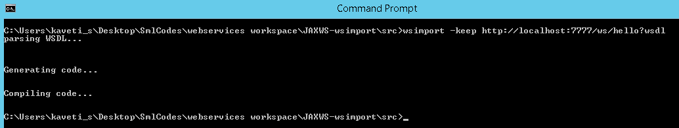

By running this it is generated Service Endpoint files as below

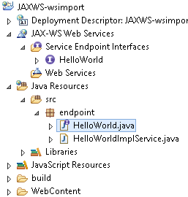

// HelloWorld.java

**package** endpoint;

**import** javax.jws.WebMethod;

**import** javax.jws.WebParam;

**import** javax.jws.WebResult;

**import** javax.jws.WebService;

**import** javax.jws.soap.SOAPBinding;

**import** javax.xml.ws.Action;

/\*\*

\* This class was generated by the JAX-WS RI. JAX-WS RI 2.2.9-b130926.1035 Generated source version: 2.2\*/

@WebService(name = "HelloWorld", targetNamespace = "http://endpoint/")

@SOAPBinding(style = SOAPBinding.Style.***RPC***)

**public** **interface** HelloWorld {

/\*\*

\* **@param** arg0

\* **@return** returns java.lang.String

\*/

@WebMethod

@WebResult(partName = "return")

@Action(input = "http://endpoint/HelloWorld/getHelloWorldMsgRequest", output = "http://endpoint/HelloWorld/getHelloWorldMsgResponse")

**public** String getHelloWorldMsg(@WebParam(name = "arg0", partName = "arg0") String arg0);

}

**package** endpoint;

**import** java.net.MalformedURLException;

**import** java.net.URL;

**import** javax.xml.\*;

@WebServiceClient(name = "HelloWorldImplService", targetNamespace = "http://endpoint/", wsdlLocation = "http://localhost:7777/ws/hello?wsdl")

**public** **class** HelloWorldImplService **extends** Service {

**private** **final** **static** URL ***HELLOWORLDIMPLSERVICE\_WSDL\_LOCATION***;

**private** **final** **static** WebServiceException ***HELLOWORLDIMPLSERVICE\_EXCEPTION***;

**private** **final** **static** QName ***HELLOWORLDIMPLSERVICE\_QNAME*** = **new** QName("http://endpoint/", "HelloWorldImplService");

**static** {

URL url = **null**;

WebServiceException e = **null**;

**try** {

url = **new** URL("http://localhost:7777/ws/hello?wsdl");

} **catch** (MalformedURLException ex) {

e = **new** WebServiceException(ex);

}

***HELLOWORLDIMPLSERVICE\_WSDL\_LOCATION*** = url;

***HELLOWORLDIMPLSERVICE\_EXCEPTION*** = e;

}

**public** HelloWorldImplService() {

**super**(*\_\_getWsdlLocation*(), ***HELLOWORLDIMPLSERVICE\_QNAME***);

}

**public** HelloWorldImplService(WebServiceFeature... features) {

**super**(*\_\_getWsdlLocation*(), ***HELLOWORLDIMPLSERVICE\_QNAME***, features);

}

**public** HelloWorldImplService(URL wsdlLocation) {

**super**(wsdlLocation, ***HELLOWORLDIMPLSERVICE\_QNAME***);

}

**public** HelloWorldImplService(URL wsdlLocation, WebServiceFeature... features) {

**super**(wsdlLocation, ***HELLOWORLDIMPLSERVICE\_QNAME***, features);

}

**public** HelloWorldImplService(URL wsdlLocation, QName serviceName) {

**super**(wsdlLocation, serviceName);

}

**public** HelloWorldImplService(URL wsdlLocation, QName serviceName, WebServiceFeature... features) {

**super**(wsdlLocation, serviceName, features);

}

/\*\*

\* **@return** returns HelloWorld

\*/

@WebEndpoint(name = "HelloWorldImplPort")

**public** HelloWorld getHelloWorldImplPort() {

**return** **super**.getPort(**new** QName("http://endpoint/", "HelloWorldImplPort"), HelloWorld.**class**);

}

@WebEndpoint(name = "HelloWorldImplPort")

**public** HelloWorld getHelloWorldImplPort(WebServiceFeature... features) {

**return** **super**.getPort(**new** QName("http://endpoint/", "HelloWorldImplPort"), HelloWorld.**class**, features);

}

**private** **static** URL \_\_getWsdlLocation() {

**if** (***HELLOWORLDIMPLSERVICE\_EXCEPTION*** != **null**) {

**throw** ***HELLOWORLDIMPLSERVICE\_EXCEPTION***;

}

**return** ***HELLOWORLDIMPLSERVICE\_WSDL\_LOCATION***;

}

}

Now, create a Java web service client which depends on the above generated files

**package** client;

**import** endpoint.HelloWorld;

**import** endpoint.HelloWorldImplService;

**public** **class** WSImportClinet {

**public** **static** **void** main(String[] args) {

HelloWorldImplService service = **new** HelloWorldImplService();

HelloWorld helloWorld = service.getHelloWorldImplPort();

String output =helloWorld.getHelloWorldMsg("Iam WSIMPORT Message");

System.out.println(output); }

}

Run this application we will get following Output

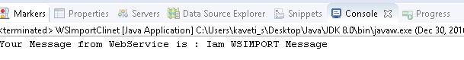

### 2.5.2 wsgen tool

The wsgen tool is used to parse an existing web service implementation class and generates required files (JAX-WS portable artifacts) for web service deployment. This wsgen tool is available in $JDK/bin folder.

2 common use cases for wsgen tool:

1. ***Generates JAX-WS portable artifacts (Java files) for web service deployment.***
2. ***Generates WSDL and xsd files***
3. ***Create web service client for testing***

We need to create web service implementation class, remaing files will be generated by wsgen tool

**package** endpoint;

**import** javax.jws.WebMethod;

**import** javax.jws.WebService;

@WebService

**public** **class** RandomNumber {

@WebMethod

**public** String getRandomNumber() {

**return** "Random Number Is : " + Math.*random*();

}

}

1. Generates JAX-WS portable artifacts (Java files) for web service deployment.

To generate all the JAX-WS portable artifacts for above web service implementation class (RandomNumber.java), use following command by going src folder from command prompt

**>wsgen -verbose -keep -cp . endpoint.RandomNumber**

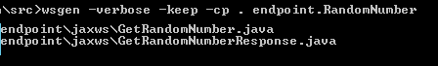

It will generate 2 .java files & 2 .class files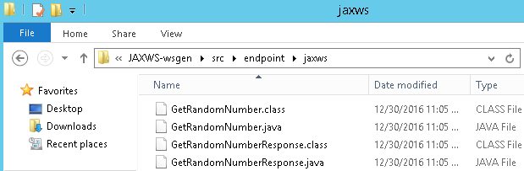

**//** GetRandomNumber.java

**package** endpoint.jaxws;

**import** javax.xml.bind.annotation.XmlAccessType;

**import** javax.xml.bind.annotation.XmlAccessorType;

**import** javax.xml.bind.annotation.XmlRootElement;

**import** javax.xml.bind.annotation.XmlType;

@XmlRootElement(name = "getRandomNumber", namespace = "http://endpoint/")

@XmlAccessorType(XmlAccessType.***FIELD***)

@XmlType(name = "getRandomNumber", namespace = "http://endpoint/")

**public** **class** GetRandomNumber {

}

**//** **GetRandomNumberResponse.java**

**package** endpoint.jaxws;

**import** javax.xml.bind.annotation.XmlAccessType;

**import** javax.xml.bind.annotation.XmlAccessorType;

**import** javax.xml.bind.annotation.XmlElement;

**import** javax.xml.bind.annotation.XmlRootElement;

**import** javax.xml.bind.annotation.XmlType;

@XmlRootElement(name = "getRandomNumberResponse", namespace = "http://endpoint/")

@XmlAccessorType(XmlAccessType.***FIELD***)

@XmlType(name = "getRandomNumberResponse", namespace = "http://endpoint/")

**public** **class** GetRandomNumberResponse {

@XmlElement(name = "return", namespace = "")

**private** String \_return;

/\*\*

\*

\* **@return** returns String

\*/

**public** String getReturn() {

**return** **this**.\_return;

}

/\*\*

\*

\* **@param** \_return

\* the value for the \_return property

\*/

**public** **void** setReturn(String \_return) {

**this**.\_return = \_return;

}

}

2. Genarates WSDL and xsd

To generate WSDL and xsd files for above web service implementation class (RandomNumber.java), add an extra **-wsdl** in the wsgen command



In this case it will generate 6 files (**2 java +2 class + 1 WSDL + 1 schema.xsd**). files under src/ folder are 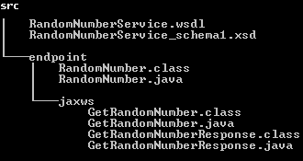

**RandomNumberService\_schema1.xsd**

<?xml version=*"1.0"* encoding=*"UTF-8"* standalone=*"yes"*?>

<xs:schema version=*"1.0"* targetNamespace=*"http://endpoint/"* xmlns:tns=*"http://endpoint/"* xmlns:xs=*"http://www.w3.org/2001/XMLSchema"*>

<xs:element name=*"getRandomNumber"* type=*"tns:getRandomNumber"*/>

<xs:element name=*"getRandomNumberResponse"* type=*"tns:getRandomNumberResponse"*/>

<xs:complexType name=*"getRandomNumber"*>

<xs:sequence/>

</xs:complexType>

<xs:complexType name=*"getRandomNumberResponse"*>

<xs:sequence>

<xs:element name=*"return"* type=*"xs:string"* minOccurs=*"0"*/>

</xs:sequence>

</xs:complexType>

</xs:schema>

**RandomNumberService.wsdl**

<?xml version=*"1.0"* encoding=*"UTF-8"* standalone=*"yes"*?>

<!-- Generated by JAX-WS RI (http://jax-ws.java.net). RI's version is JAX-WS RI 2.2.9-b130926.1035 svn-revision#5f6196f2b90e9460065a4c2f4e30e065b245e51e. -->

<definitions targetNamespace=*"http://endpoint/"* name=*"RandomNumberService"* xmlns=*"http://schemas.xmlsoap.org/wsdl/"* xmlns:wsp=*"http://www.w3.org/ns/ws-policy"* xmlns:wsp1\_2=*"http://schemas.xmlsoap.org/ws/2004/09/policy"* xmlns:tns=*"http://endpoint/"* xmlns:xsd=*"http://www.w3.org/2001/XMLSchema"* xmlns:soap=*"http://schemas.xmlsoap.org/wsdl/soap/"* xmlns:wsam=*"http://www.w3.org/2007/05/addressing/metadata"*>

<types>

<xsd:schema>

<xsd:import namespace=*"http://endpoint/"* schemaLocation=*"RandomNumberService\_schema1.xsd"*/>

</xsd:schema>

</types>

<message name=*"getRandomNumber"*>

<part name=*"parameters"* element=*"tns:getRandomNumber"*/>

</message>

<message name=*"getRandomNumberResponse"*>

<part name=*"parameters"* element=*"tns:getRandomNumberResponse"*/>

</message>

<portType name=*"RandomNumber"*>

<operation name=*"getRandomNumber"*>

<input wsam:Action=*"http://endpoint/RandomNumber/getRandomNumberRequest"* message=*"tns:getRandomNumber"*/>

<output wsam:Action=*"http://endpoint/RandomNumber/getRandomNumberResponse"* message=*"tns:getRandomNumberResponse"*/>

</operation>

</portType>

<binding name=*"RandomNumberPortBinding"* type=*"tns:RandomNumber"*>

<soap:binding transport=*"http://schemas.xmlsoap.org/soap/http"* style=*"document"*/>

<operation name=*"getRandomNumber"*>

<soap:operation soapAction=*""*/>

<input>

<soap:body use=*"literal"*/>

</input>

<output>

<soap:body use=*"literal"*/>

</output>

</operation>

</binding>

<service name=*"RandomNumberService"*>

<port name=*"RandomNumberPort"* binding=*"tns:RandomNumberPortBinding"*>

<soap:address location=*"REPLACE\_WITH\_ACTUAL\_URL"*/>

</port>

</service>

</definitions>

All files are ready.we have to write Publisher class to publish the WSDL document

**package** endpoint;

**import** javax.xml.ws.Endpoint;

**public** **class** RandomNumberPublisher {

**public** **static** **void** main(String[] args) {

Endpoint.*publish*("http://localhost:8888/ws/wsgen", **new** RandomNumber());

System.***out***.println("Service is published!");

}

}

Run as Java Application. It will shows output as Service is published!

[**http://localhost:8888/ws/wsgen?wsdl**](http://localhost:8888/ws/wsgen?wsdl) **it is as same as generated WSDL document**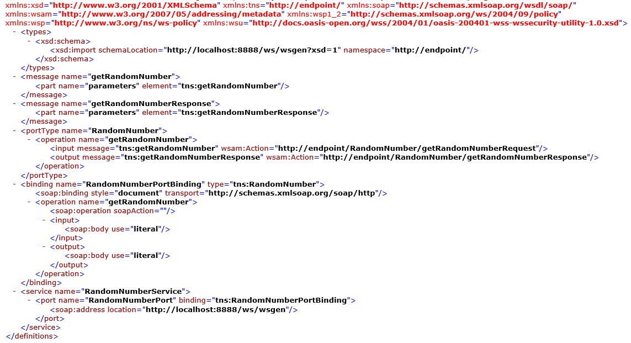

Finally Note these

Wsimport 🡪 Uses the WSDL, generates java code for the service/client implementation.

Wsgen 🡪 Uses compiled code, generates WSDL (and artifacts)

## 2.6 JAX-WS Examples

JAX-WS Handler

SOAP handler is a SOAP message interceptor, which is able to intercept incoming or outgoing SOAP message and manipulate its values.

* [Part 1 : JAX-WS – SOAP handler in server side](http://www.mkyong.com/webservices/jax-ws/jax-ws-soap-handler-in-server-side/)  
  In this article, we show you how to create a SOAP handler and attach it in server side, to retrieve the mac address in SOAP header block from every incoming SOAP message. And do validation to allow only computer with MAC address “90-4C-E5-44-B9-8F” to access this published service.
* [Part 2 : JAX-WS – SOAP handler in client side](http://www.mkyong.com/webservices/jax-ws/jax-ws-soap-handler-in-client-side/)  
  In this article, you will develop a web service client to access the published service in previous article, and attach a handler to inject client’s MAC address into header block, for every outgoing SOAP message that’s send by client side.
* [Part 3 : JAX-WS – SOAP handler testing for client and server side](http://www.mkyong.com/webservices/jax-ws/jax-ws-soap-handler-testing-for-client-and-server-side/)  
  A testing result for above two SOAP handler articles.
* [Deploy JAX-WS web services on Tomcat](http://www.mkyong.com/webservices/jax-ws/deploy-jax-ws-web-services-on-tomcat/)  
  Here’s a guide to show you how to deploy JAX-WS web services on Tomcat servlet container

# 3. JAX-RS (RESTFul web services)

JAX-RS provides the implementation of **RESTful** web services, JAX-RS is a specification for RESTful Web Services with Java and it is given by Sun.  Since it is a specification, other frameworks can be written to implement these specifications, and that includes **Jersey** from Oracle, **Resteasy** from Jboss, **CXF** from Apache, etc.

We can get the resource from RESTful service in different formats like, **HTML,XML,JSON,TEXT,PDF** and in the Image formats as well, but in real time we mainly we will prefer JSON. REST guidelines always talks about stateless communication between client and the Server. Stateless means, every single request from client to server will be considered as a fresh request. Because of this reason REST always prefers to choose HTTP as it a stateless protocol.



There are two main implementation of JAX-RS API.

1. **Jersey**
2. **RESTeasy**

**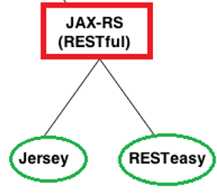**

## 3.1 JAX-RS Annotations

We have many annotations. But below are the majorly used annotations in RESTFul webservices

* **@Path(‘Path‘)**
* **@GET**
* **@POST**
* **@PUT**
* **@DELETE**
* **@Produces(MediaType.TEXT\_PLAIN [, more-types])**
* **@Consumes(type[, more-types])**
* **@PathParam()**
* **@QueryParam()**
* **@MatrixParam()**
* **@FormParam()**

[**1.@Path()**](mailto:1.@Path())

* Its a Class & Method level of annotation
* This will check the path next to the base URL

Syntax: http**://localhost:(port)/<YourApplicationName>/<UrlPattern In Web.xml>/<path>**

Here <path> is the part of URI, and this will be identified by @path annotation at class/method level.

**2.@GET**

Its a method level of annotation, this annotation indicates that the following method should respond to the HTTP GET request only, if we annotate our method with @GET, the execution flow will enter that following method if we send GET request from the client

**3.@POST**

It’s a method level of annotation, this annotation indicates that the following method should respond to the HTTP POST request only.

**4.@PUT**

It’s a method level of annotation, this annotation indicates that the following method should respond to the HTTP PUT request only.

**5.@DELETE**

It’s a method level of annotation, this annotation indicates that the following method should respond to the HTTP DELETE request only.

**6.@Produces**

It’s a method or field level annotation, This tells which **MIME** type is delivered by the method annotated with **@GET**. when ever we send a HTTP GET request to our RESTful service, it will invokes particular method and produces the output in different formats. There you can specifies in what are all formats (MIME) your method can produce the output, by using @produces annotation.

**Remember: We will use @Produces annotation for GET requests only.**

**7.@Consumes**

This is a class and method level annotation, this will define which MIME type is consumed by the particular method. it means in which format the **method can accept the input from the client**.

*@PathParam, @QueryParam, @MatrixParam* annotations will come into picture in case if we are passing the input values to the restful service through the URL

**8.@PathParam**

**http://localhost:8001/<Rest Service Name>/rest/customers/100/Satya**

Here the two parameters appear in the end of the above URL [100 & Satya], which are separated by forward slash **(/)** are called as path parameters

**9.@QueryParam**

**http://localhost:8001/…/rest/customers?custNo=100&custName=Satya**

If the client sends an input in the form of query string in the URL, then those parameters are called as Query Parameters. If you observe the above syntax, client passing **custNo=100&custName=Satya** started after question mark **(?)** symbol and each parameter is separated by **&** symbol, those parameters are called as query parameters.

**10.@MatrixParam**

**http://localhost:8001/…/rest/customers;custNo=100;custName=Satya**

Matrix parameters are another way defining the parameters to be added to URL. If you observe the above syntax, client is passing two parameters each are separated by **semicolon(;),** these parameters are called as matrix parameters. **Remember these parameters may appear any where in the path**.

**11.@** **FormParam**

If we have a HTML form having two input fields and submit button. Lets client enter those details and submit to the RESTful web service. Then the rest service will extract those details by using this **@FormParam** annotation.

## 3.2 JAX-RS JERSEY

[**Jersey**](http://jersey.java.net/), reference implementation to develope RESTful web service based on the [JAX-RS (JSR 311)](http://jsr311.java.net/nonav/releases/1.1/index.html) specification.

If we want to implement Webservices using Jersey we need to download Jersey jar files from [**Jersey**](http://jersey.java.net/) **website**

**The major change between JERSEY & RESTEASY is just changing the configuration in web.xml**

Download & install Maven, configure maven in Eclipse

Steps to Create Jersey Web Service Application

1. Create Dynamic web project in eclipse, convert that into Maven Project

2. Add Jersey jar files manually / through Maven by writing repo details in pom.xml

3. Create RESTFul webservice

4. Configure web.xml

5. Test Webservice directly by using URL / writing webservice client

### Example : JAXRS-Jersey-HelloWorld

**1. Create Dynamic web project in eclipse, convert that into Maven Project**

New → Dynamic web project → Provide project details 🡪 finish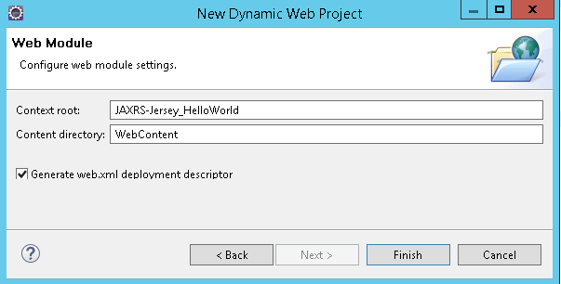

Right-click on Project →Configure → Convert to Maven Project . 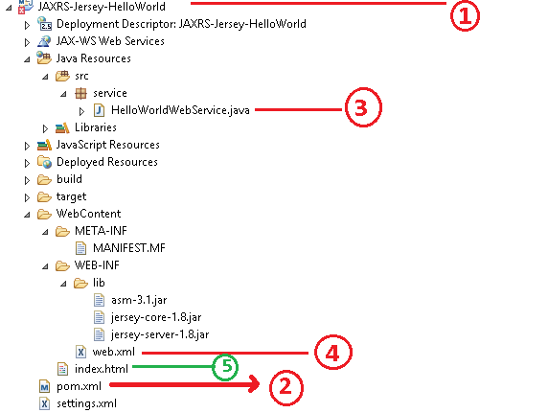

Figure 1 Directory Structure after adding all files

**2. Add Jersey jar files manually / through Maven by writing repo details in pom.xml**

Jersey is published in Java.net Maven repository. To develop Jersey REST application , just declares “jersey-server” in Maven **pom.xml**.

<project …>

<repositories>

<repository>

<id>maven2-repository.java.net</id>

<name>Java.net Repository for Maven</name>

<url>http://download.java.net/maven/2/</url>

<layout>default</layout>

</repository>

</repositories>

<dependencies>

<dependency>

<groupId>com.sun.jersey</groupId>

<artifactId>jersey-server</artifactId>

<version>1.8</version>

</dependency>

<dependency>

<groupId>com.sun.jersey</groupId>

<artifactId>jersey-client</artifactId>

<version>1.19.3</version>

</dependency>

</dependencies>

</project>

**3. Create RESTFul webservice at Server End**

**package** service;

**import** javax.ws.rs.GET;

**import** javax.ws.rs.Path;

**import** javax.ws.rs.Produces;

**import** javax.ws.rs.core.MediaType;

@Path("/hellojersey")

**public** **class** HelloWorldWebService {

// This method is called if HTML and XML is not requested

@GET

@Produces(MediaType.***TEXT\_PLAIN***)

**public** String sayPlainTextHello() {

**return** "Hello Jersey Plain";

}

// This method is called if HTML is requested

@GET

@Produces(MediaType.***TEXT\_HTML***)

**public** String sayHtmlHello() {

**return** "<h1>" + "Hello Jersey HTML" + "</h1>";

}

}

**4.Configure web.xml**

In web.xml, register “com.sun.jersey.spi.container.servlet.ServletContainer“, and puts your Jersey service folder under “**init-param**“, “com.sun.jersey.config.property.packages“.

<?xml version=*"1.0"* encoding=*"UTF-8"*?><web-app id=*"WebApp\_ID"* version=*"2.4"*

xmlns=*"http://java.sun.com/xml/ns/j2ee"*

xmlns:xsi=*"http://www.w3.org/2001/XMLSchema-instance"*

xsi:schemaLocation=*"http://java.sun.com/xml/ns/j2ee*

*http://java.sun.com/xml/ns/j2ee/web-app\_2\_4.xsd"*>

<display-name>Restful Web Application</display-name>

<servlet>

<servlet-name>jersey-serlvet</servlet-name>

<servlet-class>

com.sun.jersey.spi.container.servlet.ServletContainer

</servlet-class>

<init-param>

<param-name>com.sun.jersey.config.property.packages</param-name>

<param-value>service</param-value>

</init-param>

<load-on-startup>1</load-on-startup>

</servlet>

<servlet-mapping>

<servlet-name>jersey-serlvet</servlet-name>

<url-pattern>/rest/\*</url-pattern>

</servlet-mapping>

</web-app>

**5. Test Webservice directly by using URL / writing webservice client**

In this example, web request from “**projectURL/rest/hellojersy/**” will match to **“HelloWorldWebService“,** via @Path("/hellojersey") So we are created a test index.html conatining following url for testing purpose

Index.html

<h1>Test JERSEY WEBSERVICE </h1>

<h3><a href=*"rest/hellojersey"*>Default</a></h3>

Direct Testing URL :[**http://localhost:8080/JAXRS-Jersey-HelloWorld/rest/hellojersey**](http://localhost:8080/JAXRS-Jersey-HelloWorld/rest/hellojersey)

**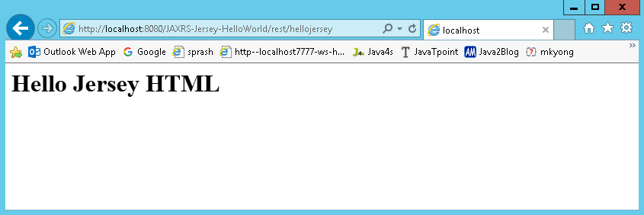**

We can write The HelloworldClientTest.java file is created inside the server application. But you can run client code by other application also by having service interface and jersey jar file.

**package** client;

**import** java.net.URI;

**import** javax.ws.rs.client.Client;

**import** javax.ws.rs.client.ClientBuilder;

**import** javax.ws.rs.client.WebTarget;

**import** javax.ws.rs.core.MediaType;

**import** javax.ws.rs.core.UriBuilder;

**import** org.glassfish.jersey.client.ClientConfig;

**public** **class** HelloworldClientTest {

**public** **static** **void** main(String[] args) {

ClientConfig config = **new** ClientConfig();

Client client = ClientBuilder.newClient(config);

WebTarget target = client.target(*getBaseURI*());

// Now printing the server code of different media type

System.***out***.println(target.path("rest").path("hellojersey").request().accept(MediaType.***TEXT\_PLAIN***).get(String.**class**));

System.***out***.println(target.path("rest").path("hellojersey").request().accept(MediaType.***TEXT\_HTML***).get(String.**class**));

}

**private** **static** URI getBaseURI() {

// here server is running on 4444 port number and project name is

// restfuljersey

**return** UriBuilder.*fromUri*("http://localhost:8080/JAXRS-Jersey-HelloWorld/rest/hellojersey").build();

}

}

**If we got 404 error , follow below steps** java.lang.ClassNotFoundException: com.sun.jersey.spi.container.servlet.ServletContainer

Right click on Project 🡪 Properties 🡪 Deployment Assembly : add : Java BuildPath Entities 🡪 Maven Dependencies 🡪 Finish

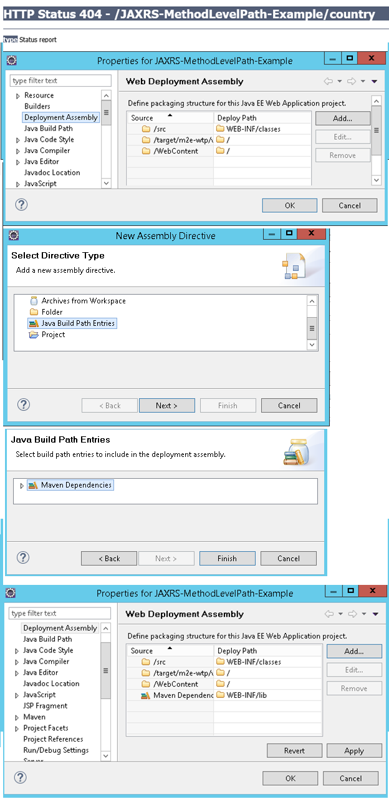

## 3.3 JAX-RS RESTEasy

[**RESTEasy**](http://www.jboss.org/resteasy)**,** JBoss project, implementation of the [**JAX-RS**](http://jsr311.java.net/) specification. In this article, we show you how to use RESTEasy framework to create a simple REST style web application

Downlaod [**RESTEasy**](http://www.jboss.org/resteasy) jars from here or add RESTEasy dependencies in POM.xml

Steps to Create RESTEasy Web Service Application

1. Create Dynamic web project in eclipse, convert that into Maven Project

2. Add RESTEasy jar files manually / through Maven by writing repo details in pom.xml

3. Create RESTFul webservice using RESTEasy

4. Configure web.xml, Register RESTEasy dependency class

5. Test Webservice directly by using URL / writing webservice client

### Example : JAXRS- RESTEasy –HelloWorld

**1.Create Dynamic web project in eclipse, convert that into Maven Project**

**Create Dynamic Web Project : New → Dynamic web project → Provide project details 🡪 finish**

**Convert into Maven Project** : Right-click on Project →Configure → Convert to Maven Project.

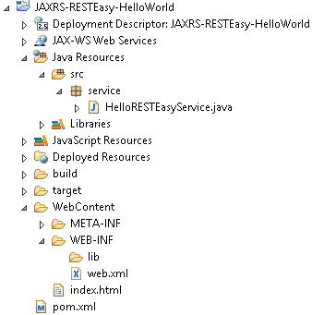

**2.Add RESTEasy jar files manually / through Maven by writing repo details in pom.xml**

Declares JBoss public Maven repository and “**resteasy-jaxrs**” in your Maven pom.xml file. That’s all you need to use **RESTEasy**.

<project xmlns="http://maven.apache.org/POM/4.0.0" xmlns:xsi="http://www.w3.org/2001/XMLSchema-instance" xsi:schemaLocation="http://maven.apache.org/POM/4.0.0 http://maven.apache.org/xsd/maven-4.0.0.xsd">

<modelVersion>4.0.0</modelVersion>

<groupId>JAXRS-RESTEasy-HelloWorld</groupId>

<artifactId>JAXRS-RESTEasy-HelloWorld</artifactId>

<version>0.0.1-SNAPSHOT</version>

<packaging>war</packaging>

<build>

<sourceDirectory>src</sourceDirectory>

<plugins>

<plugin>

<artifactId>maven-compiler-plugin</artifactId>

<version>3.5.1</version>

<configuration>

<source>1.8</source>

<target>1.8</target>

</configuration>

</plugin>

<plugin>

<artifactId>maven-war-plugin</artifactId>

<version>3.0.0</version>

<configuration>

<warSourceDirectory>WebContent</warSourceDirectory>

</configuration>

</plugin>

</plugins>

</build>

<repositories>

<repository>

<id>JBoss repository</id>

<url>https://repository.jboss.org/nexus/content/groups/public-jboss/</url>

</repository>

</repositories>

<dependencies>

<dependency>

<groupId>org.jboss.resteasy</groupId>

<artifactId>resteasy-jaxrs</artifactId>

<version>2.2.1.GA</version>

</dependency>

</dependencies>

</project>

**3.Create RESTFul webservice using RESTEasy**

**package** service;

**import** javax.ws.rs.GET;

**import** javax.ws.rs.Path;

**import** javax.ws.rs.Produces;

**import** javax.ws.rs.core.MediaType;

@Path("/helloresteasy")

**public** **class** HelloRESTEasyService {

@GET

@Produces(MediaType.***TEXT\_HTML***)

**public** String sayHtmlHello() {

**return** "<h1>" + "Hello RESTEasy Service" + "</h1>";

}

}

**4.Configure** web.xml, Register **RESTEasy dependency class**

Now, configure listener and servlet to support RESTEasy. Read this [JBoss documentation](http://docs.jboss.org/resteasy/docs/2.2.1.GA/userguide/html/Installation_Configuration.html) for details

<web-app id=*"WebApp\_ID"* version=*"2.4"*

xmlns=*"http://java.sun.com/xml/ns/j2ee"*

xmlns:xsi=*"http://www.w3.org/2001/XMLSchema-instance"*

xsi:schemaLocation=*"http://java.sun.com/xml/ns/j2ee*

*http://java.sun.com/xml/ns/j2ee/web-app\_2\_4.xsd"*>

<display-name>Restful Web Application</display-name>

<!-- Auto scan REST service -->

<context-param>

<param-name>resteasy.scan</param-name>

<param-value>true</param-value>

</context-param>

<!-- this need same with resteasy servlet url-pattern -->

<context-param>

<param-name>resteasy.servlet.mapping.prefix</param-name>

<param-value>/rest</param-value>

</context-param>

<listener>

<listener-class>

org.jboss.resteasy.plugins.server.servlet.ResteasyBootstrap

</listener-class>

</listener>

<servlet>

<servlet-name>resteasy-servlet</servlet-name>

<servlet-class>

org.jboss.resteasy.plugins.server.servlet.HttpServletDispatcher

</servlet-class>

</servlet>

<servlet-mapping>

<servlet-name>resteasy-servlet</servlet-name>

<url-pattern>/rest/\*</url-pattern>

</servlet-mapping>

</web-app>

You need to set the “resteasy.servlet.mapping.prefix” if your servlet-mapping for the resteasy servlet has a url-pattern other than “/\*“.

In above example, the resteasy servlet url-pattern is “/rest/\*“, so you have to set the “resteasy.servlet.mapping.prefix” to “/rest” as well, otherwise, you will hit resource not found error message.

Remember to set “resteasy.scan” to true, so that RESTEasy will find and register your REST service automatically.

**5.Test Webservice directly by using URL / writing webservice client**

[**http://localhost:8080/JAXRS-RESTEasy-HelloWorld/rest/helloresteasy**](http://localhost:8080/JAXRS-RESTEasy-HelloWorld/rest/helloresteasy)

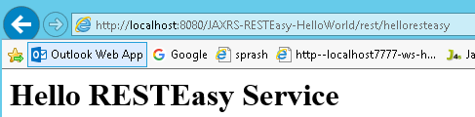

## 3.4 JAX-RS Examples

### 1: @Path (“”) annotation at Method Level Example

We can use @Path to bind URI pattern to a Java method

1. Create Dynamic web project in eclipse, convert that into Maven Project

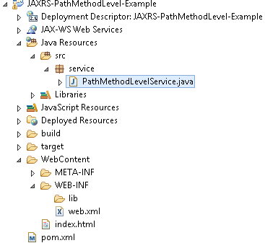

**2. Add Jersey jar files manually / through Maven by writing repo details in pom.xml**

<project xmlns="http://maven.apache.org/POM/4.0.0" xmlns:xsi="http://www.w3.org/2001/XMLSchema-instance" xsi:schemaLocation="http://maven.apache.org/POM/4.0.0 http://maven.apache.org/xsd/maven-4.0.0.xsd">

<repositories>

<repository>

<id>maven2-repository.java.net</id>

<name>Java.net Repository for Maven</name>

<url>http://download.java.net/maven/2/</url>

<layout>default</layout>

</repository>

</repositories>

<dependencies>

<!-- https://mvnrepository.com/artifact/com.sun.jersey/jersey-server -->

<dependency>

<groupId>com.sun.jersey</groupId>

<artifactId>jersey-server</artifactId>

<version>1.19.3</version>

</dependency>

<!-- https://mvnrepository.com/artifact/org.glassfish.jersey.core/jersey-client -->

<dependency>

<groupId>org.glassfish.jersey.core</groupId>

<artifactId>jersey-client</artifactId>

<version>2.25</version>

</dependency>

<!-- https://mvnrepository.com/artifact/javax.ws.rs/javax.ws.rs-api -->

<dependency>

<groupId>javax.ws.rs</groupId>

<artifactId>javax.ws.rs-api</artifactId>

<version>2.0</version>

</dependency>

</dependencies>

</project>

**3. Create RESTFul webservice**

**package** service;

**import** javax.ws.rs.GET;

**import** javax.ws.rs.Path;

**import** javax.ws.rs.Produces;

**import** javax.ws.rs.core.Response;

@Path("/country")

**public** **class** PathMethodLevelService {

@GET

@Produces("text/html")

**public** Response selectCountry() {

String output = " Default Country : <h1>INDIA</h1>";

**return** Response.*status*(200).entity(output).build();

}

@GET

@Path("/usa")

@Produces("text/html")

**public** Response selectUSA() {

String output = "Selected Country : <h1>United States of America(USA)</h1>";

**return** Response.*status*(200).entity(output).build();

}

@GET

@Path("/uk")

@Produces("text/html")

**public** Response selectUK() {

String output = "Selected Country : <h1>UNITED KINGDOM(UK)</h1>";

**return** Response.*status*(200).entity(output).build();

}

}

4. Configure web.xml

<?xml version=*"1.0"* encoding=*"UTF-8"*?>

<web-app xmlns:xsi=*"http://www.w3.org/2001/XMLSchema-instance"* xmlns=*"http://java.sun.com/xml/ns/j2ee"* xmlns:web=*"http://xmlns.jcp.org/xml/ns/javaee"* xsi:schemaLocation=*"http://java.sun.com/xml/ns/j2ee http://java.sun.com/xml/ns/j2ee/web-app\_2\_4.xsd"* id=*"WebApp\_ID"* version=*"2.4"*>

<display-name>JAXRS-PathMethodLevel-Example</display-name>

<servlet>

<servlet-name>jersey-serlvet</servlet-name>

<servlet-class>com.sun.jersey.spi.container.servlet.ServletContainer</servlet-class>

<init-param>

<param-name>com.sun.jersey.config.property.packages</param-name>

<param-value>service</param-value>

</init-param>

<load-on-startup>1</load-on-startup>

</servlet>

<servlet-mapping>

<servlet-name>jersey-serlvet</servlet-name>

<url-pattern>/rest/\*</url-pattern>

</servlet-mapping>

</web-app>

**5. Test Webservice directly by using URL / writing webservice client**

[**http://localhost:8080/JAXRS-PathMethodLevel-Example/**](http://localhost:8080/JAXRS-PathMethodLevel-Example/) **for Default country request**

[**http://localhost:8080/JAXRS-PathMethodLevel-Example/rest/country/usa**](http://localhost:8080/JAXRS-PathMethodLevel-Example/rest/country/usa) **for usa**

[**http://localhost:8080/JAXRS-PathMethodLevel-Example/rest/country/uk**](http://localhost:8080/JAXRS-PathMethodLevel-Example/rest/country/uk) **for UK**

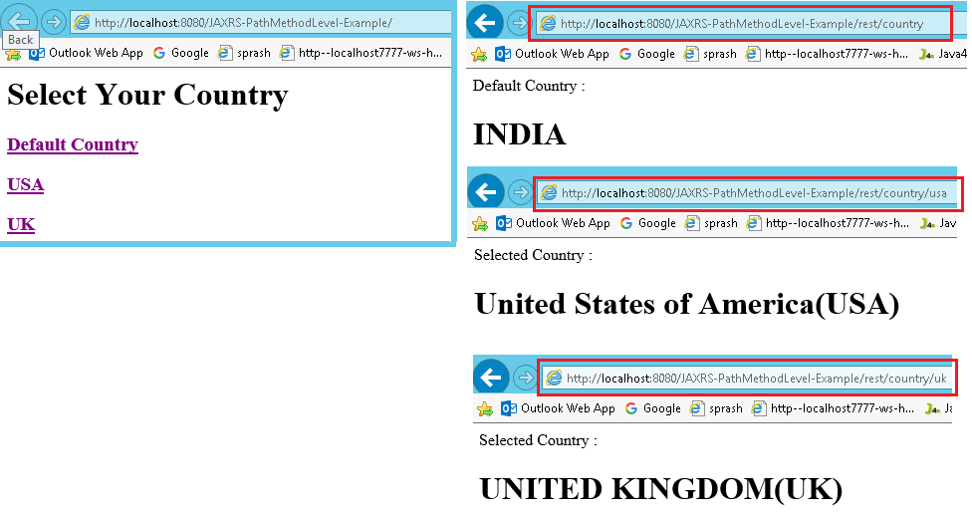

### 2: @PathParam annotation Example

In RESTful (JAX-RS) web services **@PathParam** annotation will be used to bind RESTful URL parameter values with the method arguments

**http://localhost:8001/<Rest Service Name>/rest/customers/100/Satya**

Here the two parameters appear in the end of the above URL [100 & Satya], which are separated by forward slash **(/)** are called as path parameters

We will read those URL paramters in our webservice method using

**@PathParam("paramname") String variablename**

**1. Create Dynamic web project in eclipse, convert that into Maven Project**

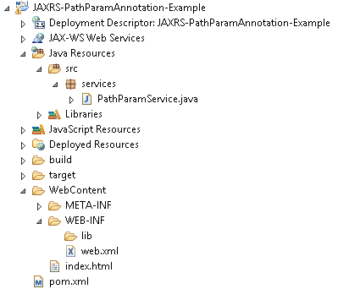

2. **Add RESTEasy jar files manually / through Maven by writing repo details in pom.xml**

<project xmlns="http://maven.apache.org/POM/4.0.0" xmlns:xsi="http://www.w3.org/2001/XMLSchema-instance" xsi:schemaLocation="http://maven.apache.org/POM/4.0.0 http://maven.apache.org/xsd/maven-4.0.0.xsd">

<modelVersion>4.0.0</modelVersion>

<groupId>JAXRS-PathParamAnnotation-Example</groupId>

<artifactId>JAXRS-PathParamAnnotation-Example</artifactId>

<version>0.0.1-SNAPSHOT</version>

<packaging>war</packaging>

<repositories>

<repository>

<id>maven2-repository.java.net</id>

<name>Java.net Repository for Maven</name>

<url>http://download.java.net/maven/2/</url>

<layout>default</layout>

</repository>

</repositories>

<dependencies>

<dependency>

<groupId>com.sun.jersey</groupId>

<artifactId>jersey-server</artifactId>

<version>1.8</version>

</dependency>

</dependencies>

<build>

<finalName>JAXRS-PathParamAnnotation-Example</finalName>

<plugins>

<plugin>

<artifactId>maven-compiler-plugin</artifactId>

<configuration>

<compilerVersion>1.5</compilerVersion>

<source>1.5</source>

<target>1.5</target>

</configuration>

</plugin>

</plugins>

</build>

</project>

3. Create RESTFul webservice using RESTEasy

**package** services;

**import** javax.ws.rs.GET;

**import** javax.ws.rs.Path;

**import** javax.ws.rs.PathParam;

**import** javax.ws.rs.Produces;

**import** javax.ws.rs.core.Response;

@Path("/students")

**public** **class** PathParamService {

@GET

@Path("{rollno}/{name}/{address}")

@Produces("text/html")

**public** Response getResultByPassingValue(

@PathParam("rollno") String rollno,

@PathParam("name") String name,

@PathParam("address") String address) {

String output = "<h1>PathParamService Example</h1>";

output = output+"<br>Roll No : "+rollno;

output = output+"<br>Name : "+name;

output = output+"<br>Address : "+address;

**return** Response.*status*(200).entity(output).build();

}

}

4. Configure web.xml, Register Jersey dependency class

<?xml version=*"1.0"* encoding=*"UTF-8"*?>

<web-app xmlns:xsi=*"http://www.w3.org/2001/XMLSchema-instance"* xmlns=*"http://java.sun.com/xml/ns/j2ee"* xmlns:web=*"http://xmlns.jcp.org/xml/ns/javaee"* xsi:schemaLocation=*"http://java.sun.com/xml/ns/j2ee http://java.sun.com/xml/ns/j2ee/web-app\_2\_4.xsd"* id=*"WebApp\_ID"* version=*"2.4"*>

<display-name>JAXRS-PathParamAnnotation-Example</display-name>

<servlet>

<servlet-name>jersey-serlvet</servlet-name>

<servlet-class>com.sun.jersey.spi.container.servlet.ServletContainer</servlet-class>

<init-param>

<param-name>com.sun.jersey.config.property.packages</param-name>

<param-value>services</param-value>

</init-param>

<load-on-startup>1</load-on-startup>

</servlet>

<servlet-mapping>

<servlet-name>jersey-serlvet</servlet-name>

<url-pattern>/rest/\*</url-pattern>

</servlet-mapping>

</web-app>

**5. Test Webservice directly by using URL / writing webservice client**

[**http://localhost:8080/JAXRS-PathParamAnnotation-Example/rest/students/101/Satya/Vijayawada**](http://localhost:8080/JAXRS-PathParamAnnotation-Example/rest/students/101/Satya/Vijayawada)

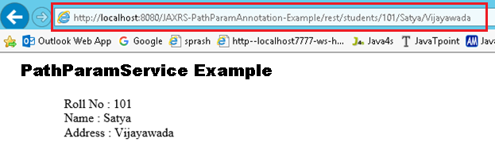

Note : In Upcomming Examples POM.XML , Web.xml are same for all applications. So iam skipping those. If any changes in those files I will mention don’t worry ☺

### 3: @QueryParam annotation Example

**http://localhost:8001/…/rest/customers?custNo=100&custName=Satya**

If the client sends an input in the form of query string in the URL, then those parameters are called as Query Parameters. If you observe the above syntax, client passing **custNo=100&custName=Satya** started after question mark **(?)** symbol and each parameter is separated by **&** symbol, those parameters are called as query parameters.

Steps to Implement this Web Service Application

**1. Create Dynamic web project in eclipse, convert that into Maven Project**

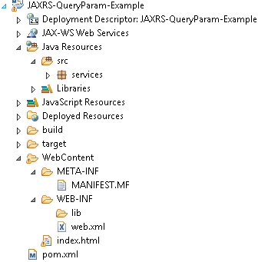

2. Add RESTEasy jar files manually / through Maven by writing repo details in **pom.xml(skip)**

**3. Create RESTFul webservice using Jersy**

**package** services;

**import** javax.ws.rs.GET;

**import** javax.ws.rs.Path;

**import** javax.ws.rs.Produces;

**import** javax.ws.rs.QueryParam;

**import** javax.ws.rs.core.Response;

@Path("/students")

**public** **class** QueryParamService {

@GET

@Produces("text/html")

**public** Response getResultByPassingValue(

@QueryParam("rollno") String rollno,

@QueryParam("name") String name,

@QueryParam("address") String address) {

String output = "<h1>QueryParamService Example</h1>";

output = output+"<br>Roll No : "+rollno;

output = output+"<br>Name : "+name;

output = output+"<br>Address : "+address;

**return** Response.*status*(200).entity(output).build();

}

}

4. Configure web.xml **(SKIPING)**

5. Test Webservice directly by using URL / writing webservice client

[**http://localhost:8080/JAXRS-QueryParam-Example/rest/students?rollno=1218&name=SATYA KAVETI&address=VIJAYAWADA**](http://localhost:8080/JAXRS-QueryParam-Example/rest/students?rollno=1218&name=SATYA%20KAVETI&address=VIJAYAWADA)

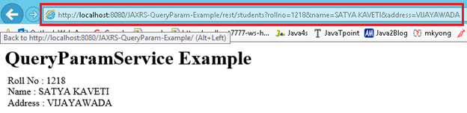

### 4.@DefaultValue Annotation

Sometimes URL doesn’t contain the values which are expected the methods. In that situation we can use @DefaultValue for passing default values to method parameters. @DefaultValue is good for optional parameter.

**package** services;

**import** javax.ws.rs.DefaultValue;

**import** javax.ws.rs.GET;

**import** javax.ws.rs.Path;

**import** javax.ws.rs.Produces;

**import** javax.ws.rs.QueryParam;

**import** javax.ws.rs.core.Response;

@Path("/students")

**public** **class** QueryParamwithDefaultvalueService {

@GET

@Produces("text/html")

**public** Response getResultByPassingValue(@DefaultValue("1000") @QueryParam("rollno") String rollno,

@DefaultValue("XXXX") @QueryParam("name") String name,

@DefaultValue("XXXX") @QueryParam("address") String address) {

String output = "<h1>QueryParamwithDefaultvalueService Example</h1>";

output = output + "<br>Roll No : " + rollno;

output = output + "<br>Name : " + name;

output = output + "<br>Address : " + address;

**return** Response.*status*(200).entity(output).build();

}

}

[**http://localhost:8080/JAXRS-DefaultValue-Example/rest/students?rollno=1218**](http://localhost:8080/JAXRS-DefaultValue-Example/rest/students?rollno=1218)

**in Above URL we are not passing Name, Address paramaeter values. So it will take Default values passed in** @DefaultValue("XXXX") annotation

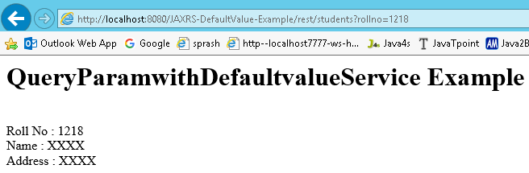

### 5:@MatrixParam annotation Example

**http://localhost:8001/…/rest/customers;custNo=100;custName=Satya**

Matrix parameters are another way defining the parameters to be added to URL. If you observe the above syntax, client is passing two parameters each are separated by **semicolon(;),** these parameters are called as matrix parameters. **Remember these parameters may appear any where in the path**

Steps to Implement this Web Service Application

1. Create Dynamic web project in eclipse, convert that into Maven Project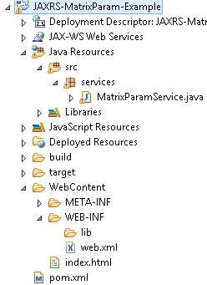

2. Add RESTEasy jar files manually / through Maven by writing repo details in **pom.xml(Skipping)**

**3. Create RESTFul webservice using Jersey**

**package** services;

**import** javax.ws.rs.\*;

**import** javax.ws.rs.core.Response;

@Path("/students")

**public** **class** MatrixParamService{

@GET

@Produces("text/html")

**public** Response getResultByPassingValue(

@MatrixParam("rollno") String rollno,

@MatrixParam("name") String name,

@MatrixParam("address") String address) {

String output = "<h1>@MatrixParam Example</h1>";

output = output+"<br>Roll No : "+rollno;

output = output+"<br>Name : "+name;

output = output+"<br>Address : "+address;

**return** Response.*status*(200).entity(output).build();

}

}

4. Configure **web.xml**, Register RESTEasy dependency class **(Skipping)**

5. Test Webservice directly by using URL / writing webservice client

[**http://localhost:8080/JAXRS-MatrixParam-Example/rest/students;rollno=1118;name=SATYA%20KAVETI;address=VIJAYAWADA**](http://localhost:8080/JAXRS-MatrixParam-Example/rest/students;rollno=1118;name=SATYA%20KAVETI;address=VIJAYAWADA)

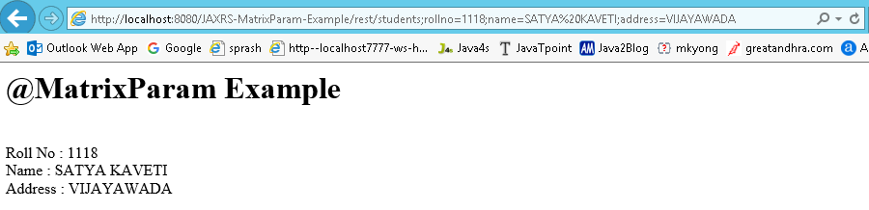

### 6:@FormParam annotation Example

If we have a HTML form having two input fields and submit button. Lets client enter those details and submit to the RESTful web service. Then the rest service will extract those details by using this **@FormParam** annotation.we can use @FormParam annotation to bind HTML form parameters value to a Java method

Steps to Implement this Web Service Application

1. Create Dynamic web project in eclipse, convert that into Maven Project

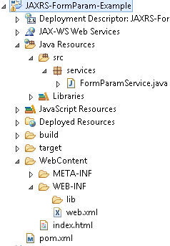

2. Configure **pom.xml, web.xml (Skipping)**

**3. Create RESTFul webservice Jersey**

**package** services;

**import** javax.ws.rs.FormParam;

**import** javax.ws.rs.POST;

**import** javax.ws.rs.Path;

**import** javax.ws.rs.Produces;

**import** javax.ws.rs.core.Response;

@Path("/students")

**public** **class** FormParamService {

@POST

@Path("/registerStudent")

@Produces("text/html")

**public** Response getResultByPassingValue(

@FormParam("rollno") String rollno,

@FormParam("name") String name,

@FormParam("address") String address) {

String output = "<h1>@FormParam Example - REGISTRATION COMPLETED!!!</h1>";

output = output+"<br>Roll No : "+rollno;

output = output+"<br>Name : "+name;

output = output+"<br>Address : "+address;

**return** Response.*status*(200).entity(output).build();

}

}

**5. Test Webservice directly by using URL / writing webservice client**

1. <http://localhost:8080/JAXRS-FormParam-Example/>
2. <http://localhost:8080/JAXRS-FormParam-Example/rest/students/registerStudent>

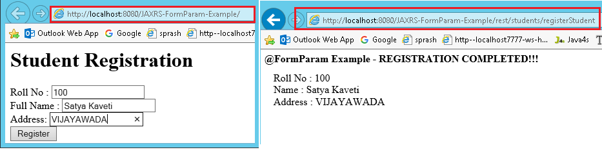

### 7: @HeaderParam & @Context to Get HTTP header in JAX-RS

 We have two ways to get HTTP request header in JAX-RS :

1. Inject directly with @HeaderParam

2.Pragmatically via @Context

### 7: Download files (text/image/pdf/execel) Using JAX-RS Example

We can download any type of files from the RESTful web services, **@produces** annotation

We should annotate our method with

* **@Produces(“text/plain“)** If you are expecting Text file as response
* **@Produces(“image/your image type[.jpg/.png/.gif]”)** for downloading any Image files
* **@Produces(“application/pdf“)** for downloading PDF files

Steps to Implement this Web Service Application

1. Create **Dynamic web project in eclipse**, **pom.xml, web.xml (Skipping)**

2. Create RESTFul webservice Jersey

**package** service;

**import** java.io.File;

**import** javax.ws.rs.GET;

**import** javax.ws.rs.Path;

**import** javax.ws.rs.Produces;

**import** javax.ws.rs.core.Response;

**import** javax.ws.rs.core.Response.ResponseBuilder;

@Path("/download")

**public** **class** FileDownloadService {

**private** **static** **final** String ***TEXT\_FILE\_PATH*** = "C:\\Users\\kaveti\_s\\textfile.txt";

**private** **static** **final** String ***IMG\_FILE\_PATH*** = "C:\\Users\\kaveti\_s\\img.jpg";

**private** **static** **final** String ***PDF\_FILE\_PATH*** = "C:\\Users\\kaveti\_s\\pdffile.pdf";

**private** **static** **final** String ***XLS\_FILE\_PATH*** = "C:\\Users\\kaveti\_s\\excel.xlsx";

//TEXTFILE DOWNLOAD

@GET

@Path("/textfile")

@Produces("text/plain")

**public** Response downloadTextFile() {

File file = **new** File(***TEXT\_FILE\_PATH***);

ResponseBuilder response = Response.*ok*((Object) file);

response.header("Content-Disposition",

"attachment; filename=\"smlcodes.log\"");

**return** response.build(); }

//IMAGE DOWNLOAD

@GET

@Path("/image")

@Produces("image/jpg")

**public** Response downloadImage() {

File file = **new** File(***IMG\_FILE\_PATH***);

ResponseBuilder response = Response.*ok*((Object) file);

response.header("Content-Disposition",

"attachment; filename=smlcodes.jpg");

**return** response.build();

}

//PDF DOWNLOAD

@GET

@Path("/pdf")

@Produces("application/pdf")

**public** Response downloadPDF() {

File file = **new** File(***PDF\_FILE\_PATH***);

ResponseBuilder response = Response.*ok*((Object) file);

response.header("Content-Disposition",

"attachment; filename=smlcodes.pdf");

**return** response.build();

}

//XLS DOWNLOAD

@GET

@Path("/xls")

@Produces("application/vnd.ms-excel")

**public** Response downloadXLS() {

File file = **new** File(***XLS\_FILE\_PATH***);

ResponseBuilder response = Response.*ok*((Object) file);

response.header("Content-Disposition",

"attachment; filename=new-smlcodes.xls");

**return** response.build();

}

}

//index.html

<h1>JAXRS-FileDownloads-Example</h1>

<h3><a href=*"download/textfile"*>TEXT FILE DOWNLOAD</a></h3>

<h3><a href=*"download/image"*>IMAGE FILE DOWNLOAD</a></h3>

<h3><a href=*"download/pdf"*>PDF FILE DOWNLOAD</a></h3>

<h3><a href=*"download/xls"*>EXCEL FILE DOWNLOAD</a></h3>

5. Test Webservice directly by using URL / writing webservice client

[**http://localhost:8080/JAXRS-FileDownloads-Example/**](http://localhost:8080/JAXRS-FileDownloads-Example/)

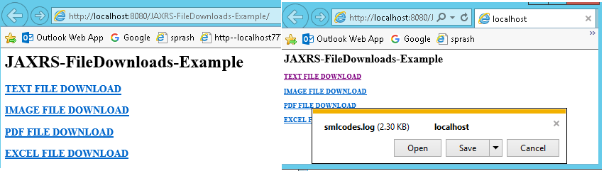

### 8: JAX-RS JSON Example Using Jersey

Steps to Implement this Web Service Application

1. Create Dynamic web project in eclipse, convert that into Maven Project

2. Configure **pom.xml, web.xml (Skipping)**

3. Create RESTFul webservice Jersey

5. Test Webservice directly by using URL / writing webservice client

### 9: JAX-RS XML Example Using Jersey

Steps to Implement this Web Service Application

1. Create Dynamic web project in eclipse, convert that into Maven Project

2. Configure **pom.xml, web.xml (Skipping)**

3. Create RESTFul webservice Jersey

5. Test Webservice directly by using URL / writing webservice client

### 10: JAX-RS RESTFul Java Clinet Example Using Jersey Client

Steps to Implement this Web Service Application

1. Create Dynamic web project in eclipse, convert that into Maven Project

2. Configure **pom.xml, web.xml (Skipping)**

3. Create RESTFul webservice Jersey

5. Test Webservice directly by using URL / writing webservice client

## 3.5 JAX-RS Real Time Examples

[File upload example in RESTEasy](http://www.mkyong.com/webservices/jax-rs/file-upload-example-in-resteasy/)

[XML example with Jersey + JAXB](http://www.mkyong.com/webservices/jax-rs/download-xml-with-jersey-jaxb/)

[JSON example with Jersey + Jackson](http://www.mkyong.com/webservices/jax-rs/json-example-with-jersey-jackson/)

**RESTful Java clients**

Create a RESTful Java client to perform “GET” and “POST” request to manipulate json data.

* [RESTful Java client with java.net.URL](http://www.mkyong.com/webservices/jax-rs/restfull-java-client-with-java-net-url/)
* [RESTful Java client with Apache HttpClient](http://www.mkyong.com/webservices/jax-rs/restful-java-client-with-apache-httpclient/)
* [RESTful Java client with RESTEasy client](http://www.mkyong.com/webservices/jax-rs/restful-java-client-with-resteasy-client-framework/)
* [RESTful Java client with Jersey client](http://www.mkyong.com/webservices/jax-rs/restful-java-client-with-jersey-client/)

# References

JAX-WS

<http://www.java2blog.com/2013/03/soap-web-service-tutorial.html>

[https://examples.smlcodes.com/enterprise-java/jws/jax-ws-annotations-example/](https://examples.javacodegeeks.com/enterprise-java/jws/jax-ws-annotations-example/)

<http://cxf.apache.org/docs/developing-a-service.html>

<https://docs.oracle.com/cd/E13222_01/wls/docs92/webserv/annotations.html>

<http://docs.oracle.com/javaee/5/api/javax/jws/WebService.html>

<https://jax-ws.java.net/jax-ws-ea3/docs/annotations.html>

JAX-RS

<http://www.java4s.com/web-services/restful-web-services-jax-rs-annotations/>

<http://www.mkyong.com/tutorials/jax-rs-tutorials/>

Examples

<http://www.mkyong.com/tutorials/jax-rs-tutorials/>

<http://www.java4s.com/web-services/>